EXPT NO:5 | DASHBOARD DESIGNING
DATE: 24.01.2026 | DASHBOARD DESIGNING

PRE-LAB QUESTIONS
1. How do dashboards support strategic decision-making?
Dashboards convert large data into clear KPIs, trends, and comparisons, helping leaders take faster and better decisions like improving performance, allocating budget, and planning resources.
2. What role do dashboards play in AI monitoring systems?
Dashboards act as a real-time monitoring screen for AI outputs such as alerts, predictions, anomalies, and system health, so users can track AI decisions and respond quickly.
3. Why is interactivity essential in modern dashboards?
Interactivity allows users to filter, drill-down, and explore specific insights, instead of only seeing fixed graphs, making the dashboard more useful and personalized.
4. What cognitive overload issues exist in dashboards?
Overload happens when dashboards include too many charts, too many colors, unclear labels, and unnecessary data, causing confusion and wrong interpretation.
5. How are KPIs derived from raw data?
Raw data is cleaned → aggregated → calculated using formulas (like averages, percentages) → then converted into meaningful KPIs like attendance %, pass rate, utilization rate.
OBJECTIVE: To design an interactive analytical dashboard for monitoring key metrics.
SCENARIO: An AI-based smart campus system requires a dashboard to monitor attendance, academic performance, and resource utilization in real time.
IN-LAB TASKS (Using PowerBI)
• Design KPI cards for attendance and performance
• Implement filters by department and semester
• Link multiple views for drill-down analysis
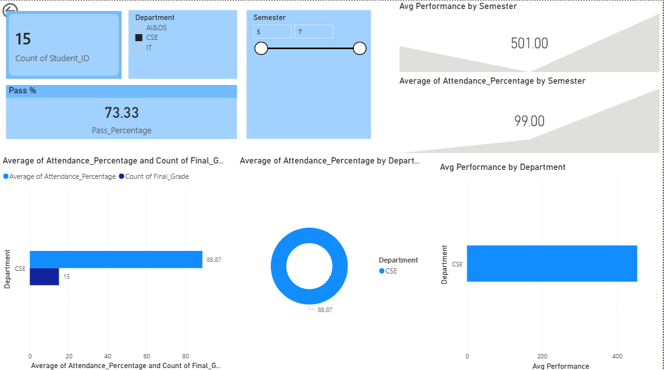

POST-LAB QUESTIONS
1. How does interactivity improve analytical depth?
Interactivity allows users to filter and drill down into specific data.
It helps compare departments/semesters and identify patterns easily.
This gives deeper insights instead of only summary-level information.
2. Which KPIs are critical for academic monitoring?
Attendance %, average marks/GPA, and pass rate are key academic KPIs.
At-risk students count helps detect low-performing students early.
Resource utilization and subject-wise performance improve tracking.
3. What design principles prevent information overload?
Use only important KPIs and avoid adding too many charts.
Maintain clean layout, proper spacing, and consistent colors.
Use drill-down and tooltips instead of displaying everything at once.
4. How can dashboards be integrated with AI alerts?
AI can detect anomalies like low attendance or poor performance trends.
Alerts can be shown as notifications, warning cards, or highlighted visuals.
This helps management take quick action based on real-time insights.
5. How do dashboards enhance transparency in institutions?
Dashboards show real-time performance and attendance clearly to all stakeholders.
They improve accountability by tracking department and student progress.
This builds trust and supports data-driven decision-making in campus systems.

ASSESSMENT
Description | Max Marks | Marks Awarded
Pre Lab Exercise | 5
In Lab Exercise | 10
Post Lab Exercise | 5
Viva | 10
Total | 30
Faculty Signature

